

# Christchurch Surgery Base Set up Document

|  |  |  |
| --- | --- | --- |
| **Version:** | **Owner:** | **Created:** |
| 1.0 | Nickey Walshaw | Jan 2025 |
| **Published:** | **Approving Director:** | **Next Review** |
| 04.02.2025 | Lucy Grinnell | 04.02.2026 |

# Contents

Location 3

Opening up Procedure for Hosts 5

Locking up procedure 8

Staff Facilities 9

Medical Equipment Use 9

Drugs Management 9

Car Parking 9

Cleaning 10

Computer Log ins 10

Video consultation equipment 12

Headsets 12

Telephone Information 13

Printing prescriptions from Adastra. 16

First Aid Kit and Accident Book 17

Visitors Book 17

Fire Protocol and Procedures 17

Fire Alarm Tests 17

Personal alarms in clinical rooms and reception 17

Business Continuity Box 17

Handwashing Kit 17

Hearing and Sight Impaired patients 18

Appendicies 19

## Location

SevernSide’s Christchurch Surgery Treatment Centre is located on the ground floor of Christchurch Surgery, North Street, Downend BS16 5SG

### Site Contacts

Contact details to be on BitWarden for access by SM/OCM when required.

### Opening Times

The Severnside IUC OOH Christchurch Surgery Treatment Centre operates between the hours of 18.15 -08.00 Monday-Friday and 24hrs over the weekend and Bank Holidays. Christchurch Surgery is our overnight base for the South Gloucestershire area.

### Space Allocation

SevernSide has access to six clinical consulting rooms, room 5, 6, 7 and 8 which are located along and at the end of the corridor on the right as you face the reception area, and rooms 1 and 2 which are located to the left of the reception area.

Room 1 is the isolation room, where patients with infectious symptoms will be seen.

### Reception Area

The reception area is located immediately as you enter the Surgery through the main entrance. This is a shared area with the Christchurch Surgery team, although it will be very infrequent when the two services are working at the same time. There are two PCs on reception, one will be configured to be used by SevernSide. The PC which the SevernSide Host should use is located on the right-hand side of reception desk (looking out into reception).

### Store Rooms

Our Storage areas are located in the old pharmacy. Access to the old pharmacy area is via a corridor to the left of Reception, running past rooms 1 and 2. SevernSide will have exclusive use of the old pharmacy area. There are digital locks on both of the storerooms.

All Severnside equipment is kept within these storerooms. The main storeroom will house three drug cupboards (controlled drug cupboard, drug cupboard and liquid medication cabinet). Along one wall of the room will be shelving which will hold consumable equipment stocks. Medication for the car will be kept in this store room.

The smaller storage room will house all the driver’s equipment (excluding medication), as well as the rugged laptop and driver mobile phone.

### Security

Public access to the Surgery in the out of hours periods will be restricted at the main entrance doors and access enabled using an automatic door release mechanism operated from Reception

### Patient Water/Refreshments

There is a water dispenser in the Waiting room area behind reception.

### Toilets

Staff & Patient toilets are located adjacent to rooms 1 and 2. There is a toilet which is adapted and equipped for use by those with a disability and as a baby changing facility.

### Sluice Facility

The sluice facility is located to the right of the main consulting rooms, in the Surgery Treatment room area. All testing of urine samples should be carried out in the sluice room and never in consulting rooms.

The SOP for urine samples needs to be followed without exception. Samples should not be poured down the sink in the sluice facility. The screw lid should be replaced on the sample pot after testing and disposed of in clinical waste bin.

Patients who arrive at base with samples in containers should be asked to decant into a urine sample pot and be requested to take their own container home for disposal

### Breastfeeding

There is no dedicated breast- feeding room. Consulting rooms 3 or 4 are available for this if and when required.

### Access

Patient access is through the main entrance of the Surgery via the main doors off North Street. As per our patient arrival process, patients should upon arrival, call the Host mobile number, before entering. The Host should then invite the patient into the consulting room when it is ready.

There is an automatic door entrance system which will be controlled from behind the reception desk and buzzer/intercom system.

### Bike Storage

There is a bike shed available to staff to store their bikes.

This is at the rear of the old pharmacy. Combination lock for access is 1379.

## Opening up Procedure for Hosts

* On arrival request that surgery reception staff open the blue shutter door between surgery and old pharmacy
* Go to the rear entrance to the old pharmacy via the path around the rear of the surgery building

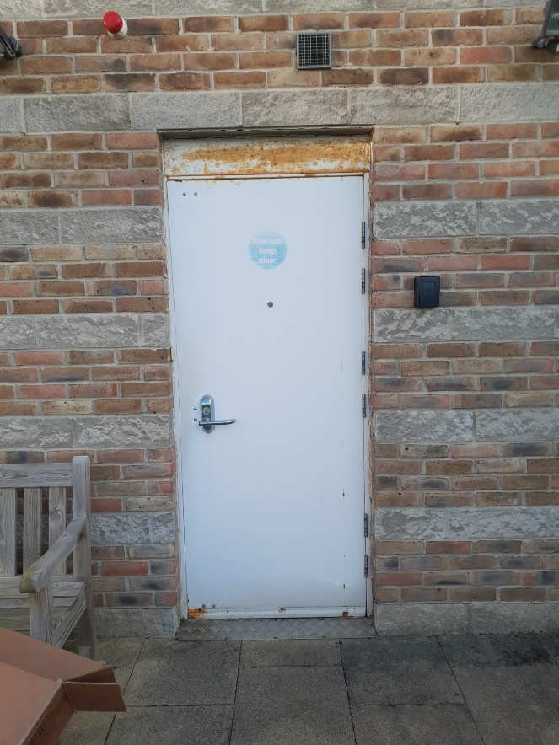

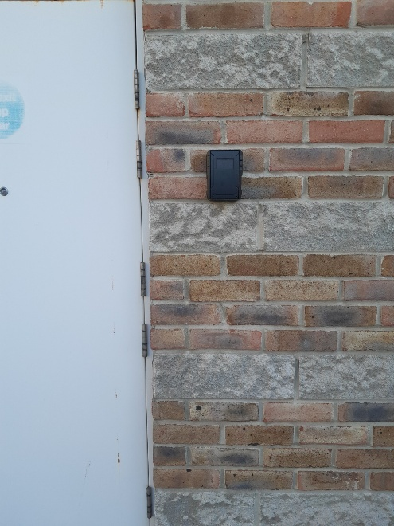

Take key out of key safe

* Unlock the door with key – open door and enter old pharmacy
* De activate intruder alarm in the old pharmacy

* Whilst the outside door is open, lock the door from the outside (to reset the deadlock)
* Replace door key in keysafe
* Re-enter old pharmacy and ensure door is closed securely behind you
* Switch on lights in old pharmacy

* Open main storeroom

* Collect the Host trolley from the storeroom
* Open white shutters leading into surgery main building

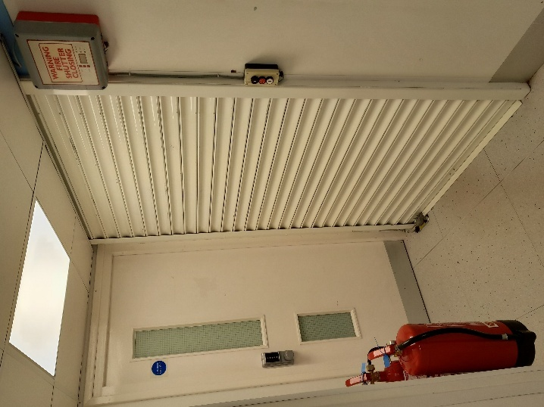

* Move host trolley into reception area
* Set up the PCs in the consulting rooms 5 and 6 and load Adastra, EMIS, MOTD and the Clinical Toolkit for the clinician. Set up Telephony and video consulting equipment for each PC including headsets and Webcams
* Log onto the Host PC (right hand side of reception) and log into Adastra and telephony.
* Log into Radar and check the rota to identify clinical and operational rota.
* Switch main entrance automatic door release mechanism to ON
* Collect the Resus bag, blood glucose box and paediatric sats monitor and leave them in front of room 9.
* Collect an equipment box for each room from the storeroom. Ensure room 1 (Isolation room) has the appropriate box PPE trolley to be located outside of room 1. Check each box has sufficient stock and replace from storeroom if not. Clean all non-consumable equipment with Clinell wipes. Allocate clinical box to each clinician on their arrival
* When cleaning has finished set up the PCs in the consulting rooms 7, 8 and 2 and load Adastra, EMIS, MOTD and the Clinical Toolkit for the clinician. Set up Telephony and video consulting equipment for each PC including headsets and Webcams
* Complete the tasks on the Daily Equipment checklist, signing against each item when complete as per the Host role requirements

## Locking up procedure

* Check that all computers are logged off and that any are switched back to surgery PC’s
* Check all areas used by SevernSide to ensure all equipment is cleared away – including video consulting equipment such as webcams and headsets.
* Check the sluice facility to ensure it has been left tidy and that no samples have been left behind
* Switch main entrance automatic door release mechanism to OFF
* Return all SevernSide equipment to the storeroom
* Ensure both drug cupboards and the safe are locked and secure
* Return all keys to the keysafe and ensure that this is locked- double checking the handle once locked to ensure it is secure
* Ensure Storeroom door is closed and secure
* Inform Surgery reception staff that they can close the blue shutter that leads from the surgery in to the old pharmacy
* Close the white shutter door from the old pharmacy to the surgery
* Set intruder alarm for old pharmacy area
* Leave via the rear door to old pharmacy
* Lock the door using key in keysafe
* Put key back into keysafe

## Staff Facilities

The kitchen is located in the old pharmacy area and is exclusively for SevernSide use. It is the responsibility of all SevernSide colleagues to keep the kitchen area clean and tidy. There is a table and chairs in the old pharmacy for use during break times. We will need to ensure that the waste bin in the kitchen is emptied when required. Waste bags need to be deposited in the bin store located within the bike storage area at the rear of the surgery.

## Medical Equipment Use

**Oxygen-** SevernSide will be providing our own large Oxygen cylinder. This will be stored in the Main store room. It will need to be moved on its trolley and be located with the resuscitation bag adjacent to the main consulting rooms.

**Car oxygen spares**- these are also located in the Drivers store room.

**Resuscitation Bag-** The resuscitation bag is stored within the storeroom and should be checked at the start of each shift to ensure that equipment is present, functioning and within date. **Emergency drugs are in the drugs cupboard and NOT in the resuscitation bag.**

**Defib-** The defib for the base is located in the Resus bag

**Dual Keytone/Blood Glucose machine-** This machine is kept in its own box which is to be kept in the Main store room and brought out and located adjacent to the main consulting rooms

**Nebulisers-** Nebulisers are kept with the dual machine and should also be brought out on shift and located adjacent to the main consulting rooms.

## Drugs Management

All medication is to be stored in the Main store room within the drug cupboards. These cupboards should be locked at all times, and keys kept in the keysafe in the main store room and only accessed when required. If clinicians use medication from stock, they must complete a Medication Issued from Stock form (available on Radar) and post this in the black prescription post-box (kept on the Host trolley).

## Car Parking

Staff cars should be parked in the car park at the rear of the surgery building, accessible via Christchurch Lane. The SevernSide vehicle car is also located at the rear of the building, opposite the rear of the old pharmacy.

Parking for patients is also available in the car park at the rear of the surgery building. There is also on the road parking close to the surgery.

## Cleaning

Christchurch surgery cleaning team will conduct a clean in the evening between 17.30-19.00 of the ground floor. This will take place Monday to Friday. There will be no cleaning over the weekend.

If there is a spill of bodily fluids, it is SevernSide’s responsibility to clean this up using the appropriate spillage kits which can be found on the bottom shelf in the main store room.

BrisDoc Clinicians and hosts are responsible for instigating and escalating the enhanced cleaning process for suspected or confirmed in line with SevernSide HCID SOP

## Computer Log ins

### Logging into Consulting Rooms - PCs and Printers

We have our own separate PC’s at the Treatment Centre which are connected to the same monitors that the practice use.

There is a black box next to each PC. This is the KVM and will allow you to switch the screens, keyboard and mouse between the SevernSide PC and the Christchurch PC by pressing the Select button. A green light will come on when the corresponding PC is enabled. BD refers to the SevernSide PC, and DHG refers to the Christchurch PC.

For our shifts we need to ensure BD is lit up/active, and as part of the close down process we need to ensure DHG is lit up/active.

* Once the KVM is switched to BD you can switch on our PC via the hard drive. Our hard drive will have a Brisdoc sticker and asset tag on it.
* Ensure both monitor screens are switched on.
* The log in screen will load automatically for all PC’s (see below)
* Enter the relevant password for each PC/room

#### PC Log ins

|  |  |  |
| --- | --- | --- |
| **PC username** | **PC password** | **Location** |
| IUC-DownendHost | **IUC2020!** | Reception |
| IUC-Downend1 | **IUC2020!** | Room 1 |
| IUC-Downend2 | **IUC2020!** | Room 2 |
| IUC-Downend5 | **IUC2020!** | Room 5 |
| IUC-Downend6 | **IUC2020!** | Room 6 |
| IUC-Downend7 | **IUC2020!** | Room 7 |

Access to Adastra and all other programs will automatically arrive on your desktop as soon as you have logged in with the above. Please ensure you open all following apps.

EMIS, MOTD, CLINICAL TOOLKIT, ADASTRA,

## Video consultation equipment

For each of the five consulting rooms (excluding room 1) there should be:

* 1 x webcam
* 1 x headset
* 1 x USB headset connector cable
* 1 x Phone jack cable

## Headsets

These are provided and stored in the Main Storeroom. In the clinical rooms these can be plugged directly into the phone in the headset port on the rear. All headsets and video consultation equipment will be kept in consulting room designated boxes.

## Telephone Information

To log into the handset, press the green button and log out the current user (if necessary)

When login is showing, depress the same button

This will show Search option. Select the button on the far left, Submit.

This will provide a list of users. Using the navigation buttons, scroll down the list.

Once you have scrolled down the appropriate Bris Doc account, hit Select button, far right

This phone is now logged in and you then need to set up Sesui Lite on the PC desktop

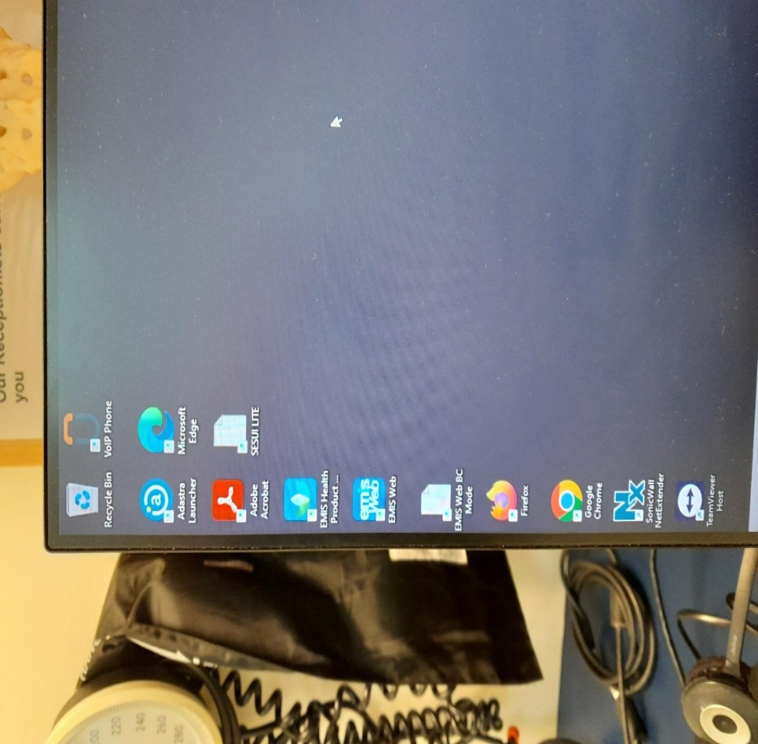Go to the desktop and find the **Sesui Lite Shortcut**. You can also find this link on the BrisDoc Weblinks page under ‘[SESUI Bases & Remote](https://c-stem.call-view.com/)’

Open this by double clicking on the icon

This will bring up the C-Stem page.

Enter Sesui Username in the top box and PIN number relevant to the phone/room you are logging into.

Hit Sign in.

This will bring up the Sesui Lite Phone System assigned to the phone.

|  |  |  |  |  |  |  |
| --- | --- | --- | --- | --- | --- | --- |
| **Room number** | **PC login username** | **PC password** | **Phone handset name** | **Sesui username** | **Sesui pin** | **DDI** |
| Reception | IUC-DownendHost | IUC2020! | BrisDocs Receptions | DEHost | 7922 | 01179709799 |
| Room 1 | IUC-Downend1 | IUC2020! | Brisdoc Clinician1 | DEClinician1 | 3471 | 01179709798 |
| Room 2 | IUC-Downend2 | IUC2020! | Brisdoc Clinician2 | DEClinician2 | 8707 | 01179709797 |
| Room 5 | IUC-Downend5 | IUC2020! | Brisdoc Clinician3 | DEClinician3 | 3130 | 01179709796 |
| Room 6 | IUC-Downend6 | IUC2020! | Brisdoc Clinician4 | DEClinician4 | 3585 | 01179709795 |
| Room 7 | IUC-Downend7 | IUC2020! | Brisdoc Clinician5 | DEClinician5 | 7833 | 01179709794 |
| Room 8 | IUC-Downend8 | IUC2020! | Brisdoc Clinician6 | DEClinician6 | 5023 | 01179709793 |

## Printing prescriptions from Adastra.

Consulting Rooms 2, 5, 6, 7 & 8 can print prescriptions from Adastra however we do carry printable scripts at the base as standard.

## First Aid Kit and Accident Book

The First Aid Kit and Accident Book can be found in the store room, on the Host trolley. Please alert the Shift Manager of any accidents being reported.

## Visitors Book

Visitors Book, lanyards and passes will be kept on the Host trolley.

## Fire Protocol and Procedures

In the event of a fire at Christchurch Surgery, you are required to following the Fire evacuation procedure (Appendix 1) The assembly point is in the car park, adjacent to the entrance off Christchurch Lane.

## Fire Alarm Tests

The Fire Alarm Test will happen during Christchurch normal surgery times.

## Personal alarms in clinical rooms and reception

There are personal alarms placed in all consulting rooms and reception desk. These must be placed on all consulting room desks during base set up

## Business Continuity Box

The Business Continuity box is located in the main store room.

## Handwashing Kit

The handwash kit is situated on the second shelf down in the large metal cabinet in the main storeroom.

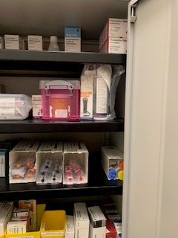

Hand

## Hearing and Sight Impaired patients

**Ensuring our services are accessible for everyone**  
  
It is important that our services are accessible and equitable for all patients. To ensure we are able to provide all patients with a high standard of care we have various tools available. The Interpreter Services and Assistance Dogs policies explain how we support patients who are deaf, need translation services and/or have an Assistance Dog.  
  
Relevant Accessibility policies can be found on RADAR.  
  
If you would like more information or support with using any of the services described above please speak to your line manager.

## Appendicies

### Appendix one – Fire Procedure

FIRE EVACUATION PROCEDURE

IF YOU DISCOVER A FIRE OR SMOKE

1. **RAISE THE ALARM** By breaking glass at the nearest call point

Fire alarm points – see Fire Evacuation Plan

1. **LEAVE IMMEDIATELY** by the nearest **SAFE** exit and go directly to the **Fire Assembly** **Point** which is at the top righthand side of the car park, next to the church

1. **CALL THE FIRE SERVICE** By ringing 999 and give your name and full address: Christchurch Surgery, North Road, Downend, South Gloucestershire, BS16 5SG
2. **DO NOT STOP** to collect personal belongings but close all windows and doors on leaving the room) if it is safe to do so) to prevent the spread of fire or smoke
3. The Host is responsible for ensuring all patients and members of the public are evacuated and checking all the toilets.
4. **CONVENE** at the **Fire Assembly Point** which is at the top righthand side of the car park, next to the church

ON HEARING THE ALARM

1. **LEAVE IMMEDIATELY** by the nearest **SAFE** exit and go directly to the **Fire Assembly Point** which is at the top righthand side of the car park, next to the church.
2. **DO NOT STOP** to collect personal belongings but close all windows and doors on leaving the room) if it is safe to do so) to prevent the spread of fire or smoke.
3. **CONVENE** at the **Fire Assembly Point** which is at the top righthand side of the car park, next to the church.

FIRE ASSEMBLY POINT

1. The Host should ring the Shift Manager to advise of Fire Evacuation Procedure and to do a roll call of colleagues on shift and patients that have arrived at base.
2. Check that the Fire Service is on their way by ensuring that a staff member has called 999. If no call has been made, a member of staff will be required to make this call. (Note that upon activation of the fire alarm, as signal is received at the monitoring station but the Fire Brigade will not attend unless they receive a 999 call.
3. **Do not re enter** the building until the Fire Service gives the all clear

### Appendix two – Resetting Intruder Alarm Procedure

* + The Control Panel is in Entrance foyer behind notice board.
  + Pull out notice board the control panel is on the wall.
  + Press the silence button then press the reset button. This should silence the alarm.

Fire Alarms – BAC Fire &Security (quote 3254107) – Christchurch (fire alarm is not monitored by the ARC)

If the alarm does not reset, you will need to ring BAC 01179583838

### Tables

|  |  |  |  |
| --- | --- | --- | --- |
| **Version** | **Date** | **Author** | **Comments** |
| DRAFT | Jan 2025 | Andrew Mellor | Draft document created |
| 1 | 04.02.2025 | Andrew Mellor | Document published |
|  |  |  |  |