|  |
| --- |
|  |
| Sesui User Guide |
|  |

|  |  |  |
| --- | --- | --- |
| **Version:** | **Owner:** | **Created:** |
| 1.6 | Sarah Eaton | 09/08/2024 |
| **Published:** | **Approving Manager:** | **Next Review** |
| 09/08/2024 | Lucy Grinnell | 09/08/2025 |

**SESUI: User Guide**

**BrisDoc's new Telephony platform**

# What is Sesui?

Sesui is BrisDoc new softphone telephone platform that will replace both landline telephones and Synety cloud call across BrisDoc and SevernSide IUC services (with the exception of Cossham and Clevedon).

Sesui is an**internet-based phone system** that can be used on any connected device that allow users to make phone calls via the internet without the need for dedicated hardware but is designed to provide the straightforward functionality of a traditional phone system.

# Roles and responsibilities within SevernSide operational teams

## Allocation of accounts

All accounts within Sesui as part of the SevernSide IUC will be generic and whilst they may be assigned to a specific desk, should remain unfixed.

The account details will be found on each desk and each card will detail both in hours and out of hours accounts, their associated pin, and a telephone extension number.

During the first few weeks of the roll out please ensure both Sesui and the telephone is logged in, any calls received to the traditional telephone line should be logged with the shift manager.

All account usernames and pins can also be accessed via Bitwarden.

Please see accessing Sesui for details on how to log in

## Call Handling within Sesui

### Incoming calls

All incoming calls will ring in hunt groups and will search for the next available call handler if the call is not answered within 15 seconds. If the Sesui screen has been minimised when the hunt group rings to that user, the screen will pop up, for other users a small notification will be displayed in the right-hand corner.

The Professional, CAS, Patient, GP Backdoor and Children’s ED (when operational) lines ring to the call handling team in-hours 08:00-18:30 and all day on the weekends.

The Professional, CAS, Patient and Children’s ED line (where operational) lines call to the WaCC team on weeknights.

Sesui displays the line that the caller dialled, allowing the call handler to answer with the appropriate standardised greeting, it will also announce the line to the caller when they answer the call.

All calls can be answered by pressing the green handset button, see taking Incoming calls.

All Call Handlers, WaCCs and Shift Managers have visibility over all incoming calls allowing them to Pluck/pickup calls if required. This enables call handers WaCCs and Shift manager to pick up any calls within the stack. See Pluck/pickup

### Transferring calls

Transferring incoming calls can be actioned in two ways, via enquiry and transfer, it is essential that calls are transferred in the correct way.

All calls that require a warm transfer should be transferred via the **enquiry** button, this will allow the call handler to talk to the person the call is going to if needed, this option should be selected for all WPL clinical calls and includes transferring paediatric calls to the nurse on charge.

Enquiry allows the call handler to be assured that call has been transferred and that the person receiving the call has answered. See Enquiry- warm transferring calls.

If a Direct transfer – i.e. GP Back door line calls, is required then the **transfer** option should be selected, this transfers the call without the option or requirement to talk to the recipient. See direct transfer

*Please note that if this is used the recipient must pick up the call within 30seconds or the call is terminated.*

### Safety calling or taking a break

When Sesui users take a break, or step away from their desk for any reason they must set their status to busy or break, so that they are not selected by Sesui to take an incoming call and causing an unnecessary delay to the caller. See busy/break

This option can also be used for safety calling as it allows the user to make outgoing calls without receiving any incoming calls. The busy/ break option has a specific option for safety calling.

### Outgoing calls

To make an outgoing or internal call within Sesui please select the green call button, this will allow you to search for a number within the address book or you can copy and paste the number directly from another source. See outgoing calls or Sesui address book

If you are making a call that requires an extension number to be selected, the keypad option will be required. See menu options in Sesui

## Shift Managing

It is all shift managers responsibility to have oversight and awareness of the calls when on shift. This includes ensuring that all call handlers are answering the calls promptly and using the busy/break function as appropriate.

Any learning should be reported promptly and issues escalated as required. All calls are recorded in Sesui, if the shift manager needs to listen to a call please refer to the shift manager handbook for guidance.

For all other essential information please see the shift manager, Sesui guide or the troubleshooting guide at the end of this document.

# Accessing Sesui

The desktop application should auto load on screen when you log into your computer account. If the application does not auto load, launch the application from the desktop.



* 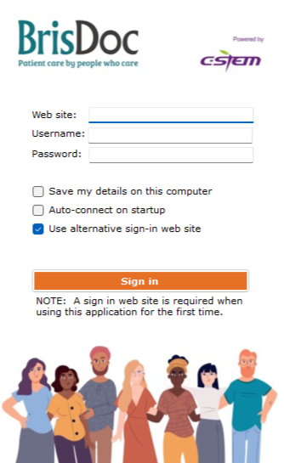When logging in for the first time the Sesui will open as follows:
* The website should be entered as: c-stem.call-view.com

Then add the username and password.

For subsequent logins you will only need to add the username and password

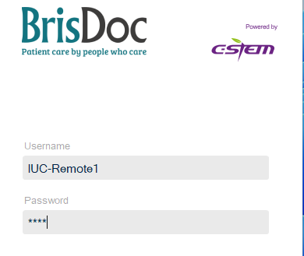

* Your Username will be assigned to you working by the shift manager

(Named accounts may be provided to Osprey staff or key operational roles such as Clinical Co-ordinator or Shift Manager)

* Your Pin will be 4 digits long.
* Please **Do Not Tick the save my credentials box**

Once you have entered your details click **‘SIGN IN’**

Sesui will appear in the following formats:

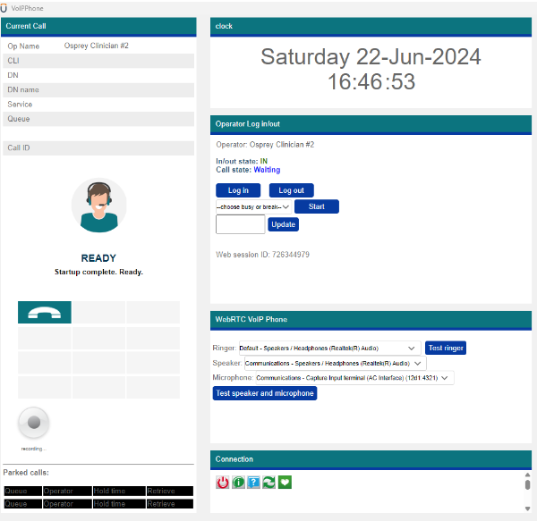

Clinical Teams

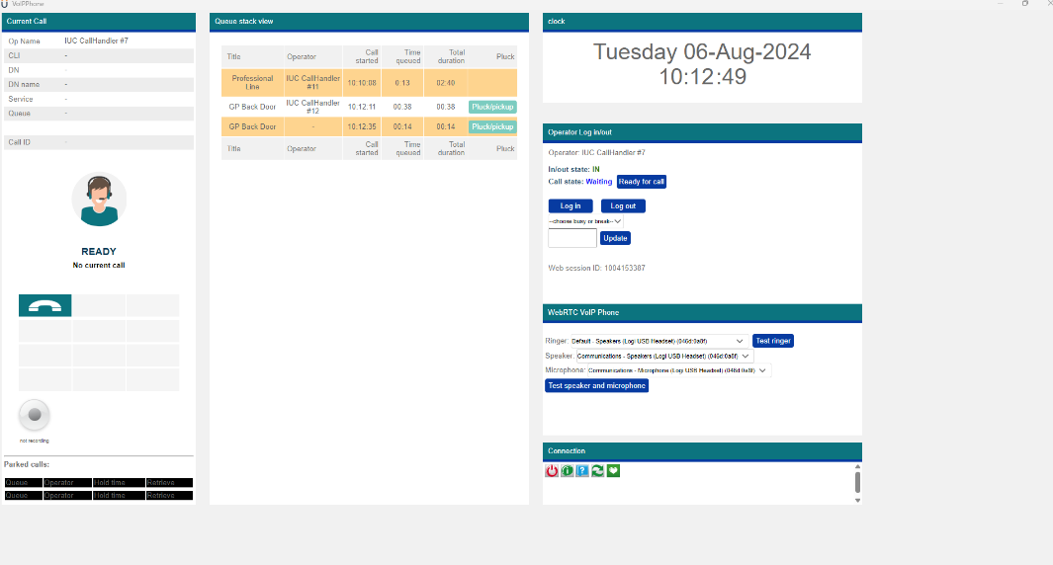

Operational Teams

Next, click **Log In** button, you are now able to make calls through the application.

# Audio Settings

Before starting it is recommended that the Audio settings are checked this is action by selecting the

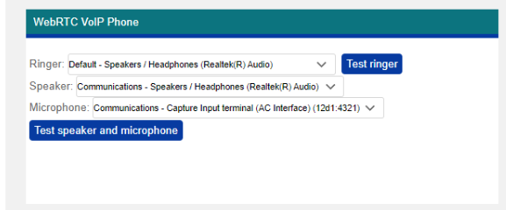

The ringer, speaker and microphone automatically connects to the correct settings, provided that the ***headset has been added prior to launching the application.***

# Incoming Calls

Sesui will notify you when a call is incoming,

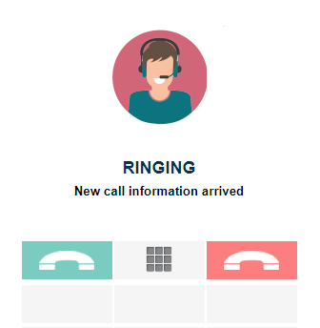

To answer a call please press the green handset button.

## Pluck/pickup

To answer an incoming call not ringing directly to that user account all operational teams have a Pluck/pickup option

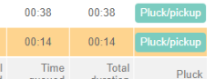

This can be used for all calls, including those to the shift manager but please note that you are only able to answer the next queued call.

# Transferring Calls

## Enquiry – Warm transferring calls

If you want to talk to a recipient before transferring a call, select the enquiry button, this will allow you talk to them

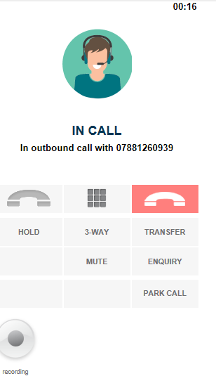

When in an enquiry, the caller is placed on hold and cannot hear your conversation, *however until you press the green handset button and whilst you are searching for the person or adding a new number the caller is still connect to you and can hear any comments made*.

After selecting either enquiry/transfer a grey call box will appear and you can either search for or add a number to transfer the call too. Callers displayed as waiting will be able to receive a call- please note that you are unable to transfer to a call to a logged out sesui account or in an outbound call.

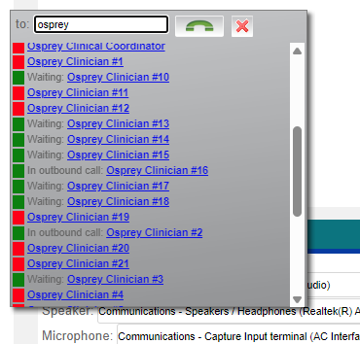

In outbound Call: unavailable

Waiting: Available for transfer

Red – not logged in

Once the recipient is ready to receive the call you can select patch

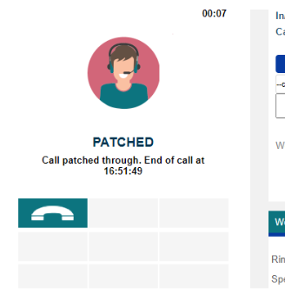

The transferred call will show as call patched

## **Sesui address book: searching for other Sesui users / internal address book**

Internal accounts or pre-programmed numbers within Sesui can be found using the search bar or internally by entering a **#** *before* the clinicians account number:

For example to find Osprey Clinician 19, type in #19

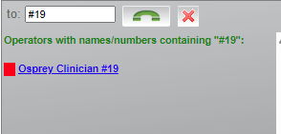

***Adding just the number of the clinician account Sesui will not find them within the search****.*

## Transfer – Direct transfer of call to recipient

If you do not need to talk to the recipient of the call, you can directly transfer the call to them by selecting transfer.

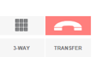

# Making Outbound Calls

To make a call, click the **green call button** and numbers to call.

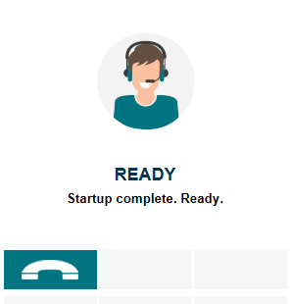

A **grey box** like this will pop up with available operators and numbers to call.

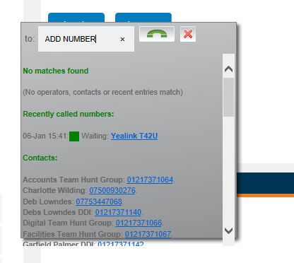

**Add the number** **you want to dial**, either by typing or copy and paste and then click the **green button** to start the call.

*Numbers can be entered with or without a space 01179370001 or 0117 9370001*

This Grey box also functions as an address book that is searchable, simply starting typing the name of the contact or the phone number into the **grey box** and the section will auto populate with matches. ***Note: You cannot call Operators that are not logged in.***

Your phone will then ring to initiate the call.

**Hang up** – Terminates the call for all parties



# Menu options in Sesui

HOLD - Places the call on hold. The patient will not hear you, and you will hear a holding beep tone. When this is activated the HOLD button will change to a RESUME, this will return your call back to the patient

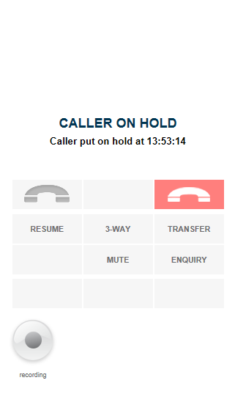

**The caller will hear a beeping noise when placed on hold**

SELECTING MENU OPTIONS WHEN IN A CALL **–** Press the keypad option 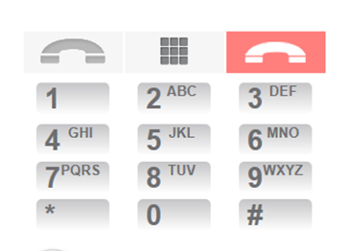the correct option can then be pressed from the keypad.

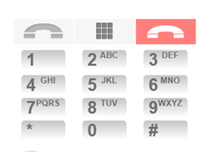

# BUSY/BREAK Function

Please use the busy or break function as appropriate when you are unavailable to make or receive calls. This is accessed by changing the status in the busy or break box and selecting the correct option:

This can also be used for safety calling.

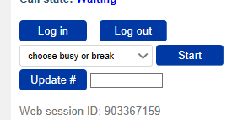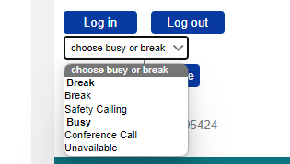

Next select Start break

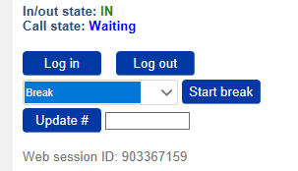

Your Status is updated: this will prevent Sesui ringing with any inbound calls and shows other users you are unavailable.

When you are ready to resume the session press **Ready for Call**

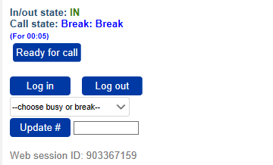

# Park Call

If you are unable to transfer a call immediately or if you wish to keep the caller on hold whilst you make a secondary call you can park the call.

Select the park call option

The call will then move to the lower part of the display screen and you are able to make other calls as required.

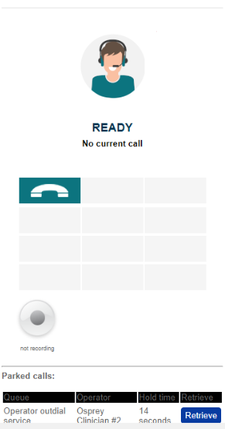

To retrieve the call, select the Retrieve option and you will be immediately be re-connected to the caller.

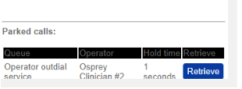

# Logging Out and Closing Application

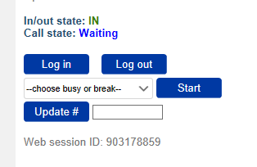At the end of your shift, you can click log out, and then click the X in the corner to close your application.

The session can be ended by either selecting

# 3-way calling

Sesui has a function for 3-way calling that can enable multiple users to be on the same call.

This function can also be used for training whilst we are waiting on training functionality within Sesui.

At any point either in an incoming or outgoing call a third individual can be called, to use this option select 3-way and use the grey box to select from the address book or add in a number.

If used for training, please ensure that the person listening is placed on mute.

# Quick Fixes & Troubleshooting

1. **Outdialler calls are not allowed whilst the operator is logged out**

If you see the following message:

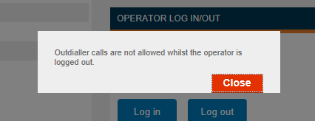

**Fix**: You have signed in but not logged in, press the log in button

1. **Our System shows that you are already signed in, or recently and unexpectedly signed out when logging in and someone else is logged in please call the shift manager.**

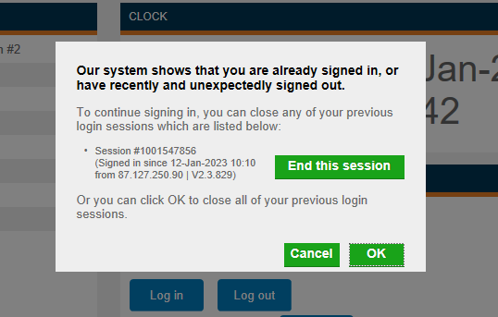

**Fix:** Contact the shift manager - Shift manager should ensure that allocated accounts have not been duplicated

1. **Your session has been ended**

**Fix:** Contact Shift Manager – someone else has logged into the account

1. **The application failed to register with your chosen audio device.**

**Fix:** Log out, plug in USB headphones and then log back in

1. **Phone number entered will not dial required number**

**Fix:** Log out and log back into the Sesui account

1. **Can not hear the call ringing in my headphones**

**Fix:** Ensure that there is no other USB connectors that can interfere with the headset, i.e. phone charging cables

1. **Caller cannot hear me or states it is hard to hear me**

**Fix:** Ensure that the headset was added prior to application launch and test the audio settings before calling

1. **Number not recognised**

**Fix:** Check the number entered/ re-dial

Report any numbers that you are not able to call to the shift manager for investigation

1. **Call to target failed**

If Call failed due to the number you are calling not having sufficient signal. The following error will show:

**Fix:** Try to call on an alternative number or ask the caller if they can hear you to move to a better signal area. Consider sending a text message asking them to move to a better location with more signal.

1. **Unable to see system in full screen/See Log In button**

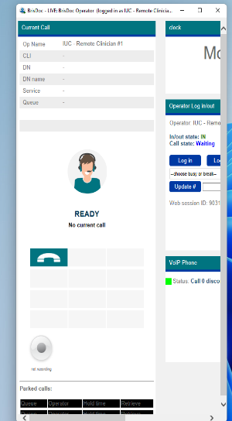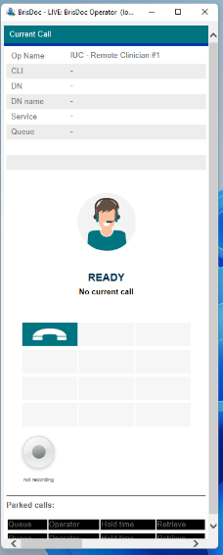

**FIX**: Expand the application

**8. What happens if I enter the incorrect log in details?**

The application will log out after 6 incorrect attempts.

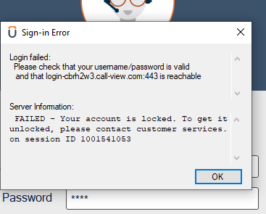

**FIX:** Call Shift Manager