**SOP: Shingles Recall for Failed Batch Texts**

**Failed batch text lists from KXS are exported to Y:\Enhanced Services\2023-24\Imms & Vacs Shingles combined**

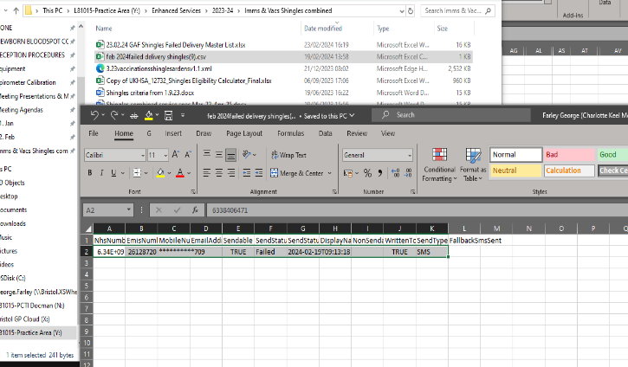

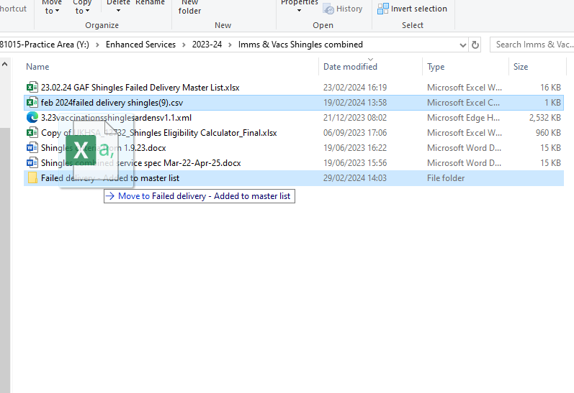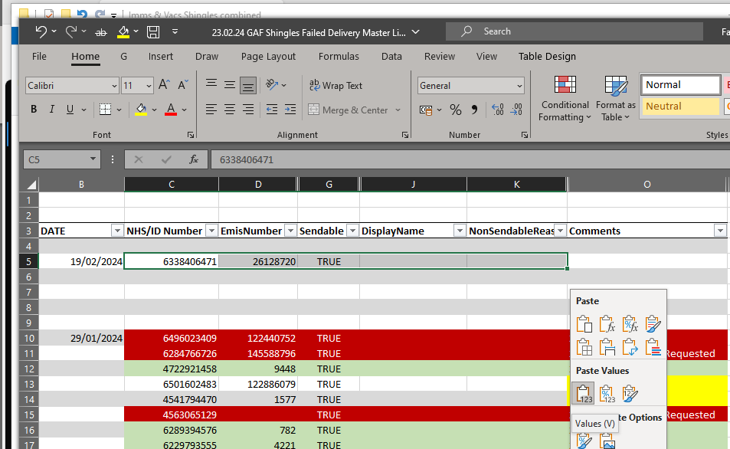

**Move the spreadsheet given by KXS into the folder “Added to Master List” folder to show it has already been added to the master list**

**Update Master spreadsheet to say if they were invited, given, booked or declined etc**

**Admin Asistant then contacts these patients – create consult in EMIS – code as herpes zoster invitation**

**Add date to master spreadsheet & paste information using “Paste ONLY VALUES” onto the Shingles Invitation Master spreadsheet.**

**Admin assistant then opens the excel spreadsheet + “CTRL+C” copy data**