**Updated 09/10/24 Deputy Lead Nurse KXS**

**Review date Oct 26**

**SOP: Pertussis in Pregnancy Recall & Updating Master Spreadsheet**

**1st Thursday of month - Run report: Ardens -> 3.2 -> Pertussis -> Patients due**

**View Results -> Export -> Export to Excel**

For all patients on new list Copy: **EMIS number, Full name, DOB, Mobile, Code term**

**Right click & PASTE ONLY VALUES at bottom of master spreadsheet.**

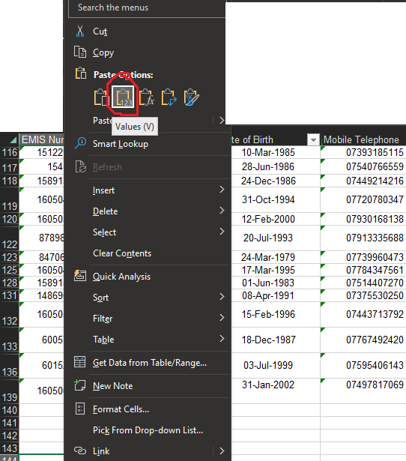

**Duplicate cells should be automatically highlighted.**

**If not go to: Conditional formatting -> Highlight rules -> duplicate values -> select only the EMIS column.**

**.01.**

**Delete all newly added duplicates. Keep new & original entries.**

**Ensure new patients’ EDD & 22wk date correct (these are initially based on first pregnancy coding to give estimates), then colour blue**

**After 2 contact attempts to task imms lead KXS or (JAG if KXS not available) who will contact patient on 3rd attempt and update spreadsheet and code ‘Pertussis vaccination in pregnancy invitation third letter’**

**Sort EDD by oldest to newest. invite those that are due for the vaccine but have not received by 22wks and code ‘Pertussis vaccination in pregnancy invitation first letter’ or ‘Pertussis vaccination in pregnancy invitation second letter’**