Clevedon
Base Set Up Guide
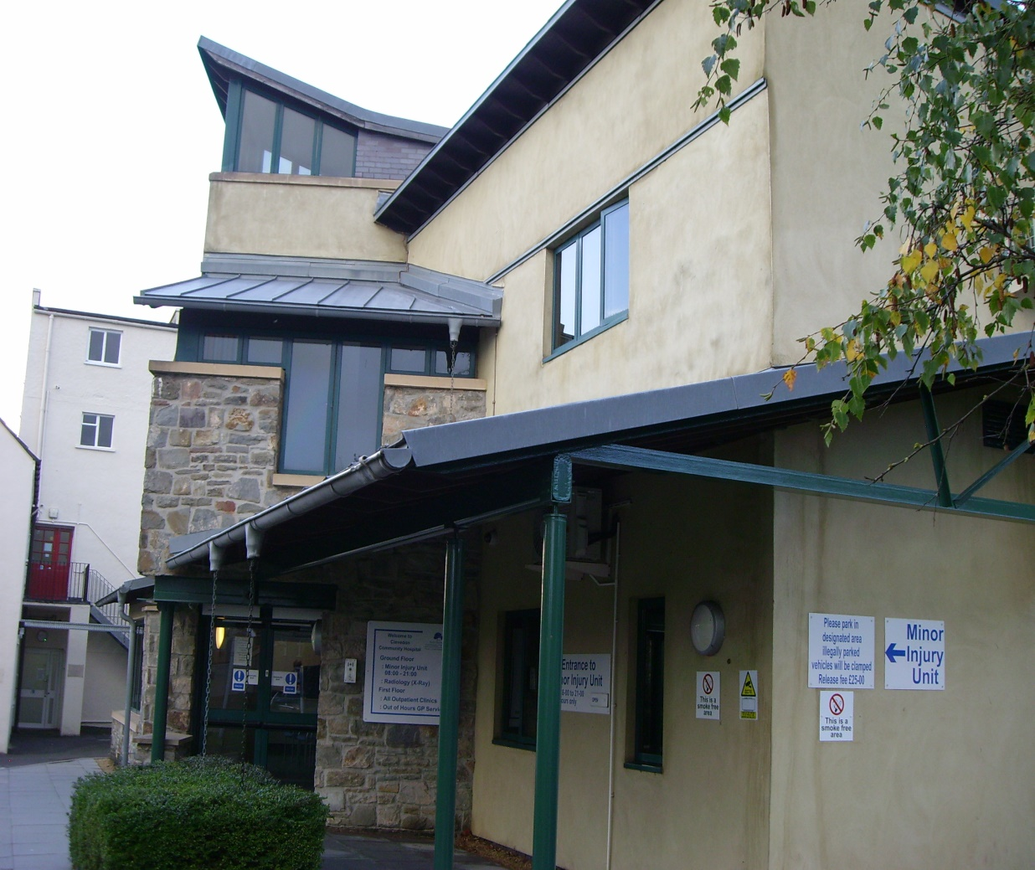

This page has been intentionally left blank
Contents

- Change Register 1
- Location 2
- Internal Layout 2
  - Reception 2
  - Waiting Area 3
  - Consulting Rooms 3
  - Consulting Room Equipment 4
  - Storage 4-5
  - Car Parking 5
- Staff/Patient Access 6
- Logging in PC’s and loading Adastra 7-8
- Logging in Telephones through Synety 9
- IT and Telephone/Fax Issues 10
- Prescription Management 10
- Medical Equipment 11
- Locking Up Procedure 12
- Staff Facilities 12
- Fire Protocol and Fire Procedures 13
- Breast Feeding 13
- Accident Book 13
- Incident Reporting 14
- Visitors Signing In Books 14
- First Aid Kit 14
- Business Continuity Kit 14
- Intranet – Radar 14
Change Register
Date created: | 12/06/19
Last Review Date:
Next Review date: | 31/05/20
Written by: | John Biddle
Approved by:

Content of document
Date | Version | Author | Change
Nov20 | V2 | Hesham.E | Updated with additional room(physio room 3)

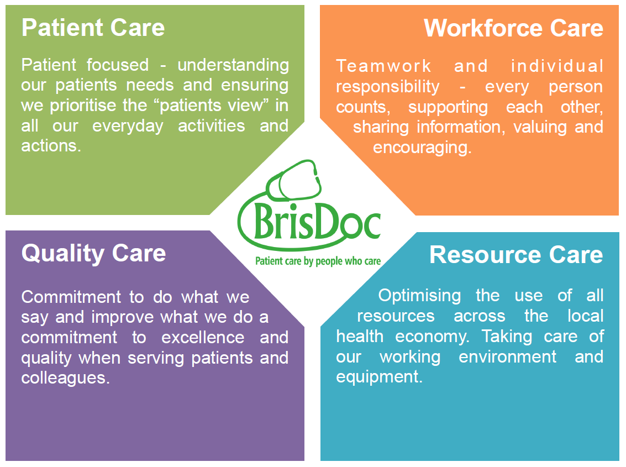

1
Location
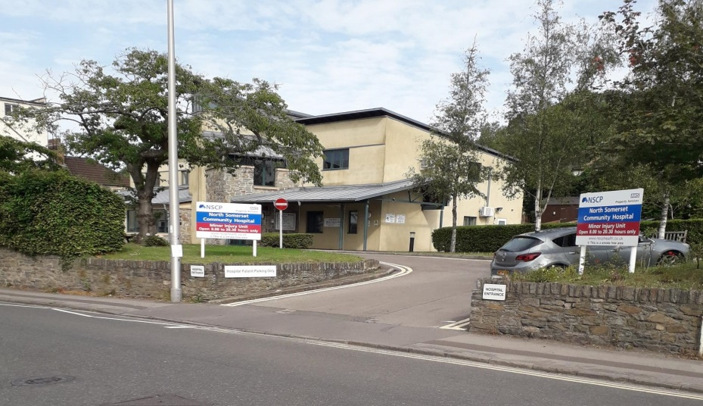
Address:- Clevedon Hospital, Old Street, Clevedon, Somerset. BS21 6BS
The GP out of Hours Service is located on the First Floor of the Minor Injuries Unit (MIU) and can be reached by lift or stairs.
Internal Layout
Reception
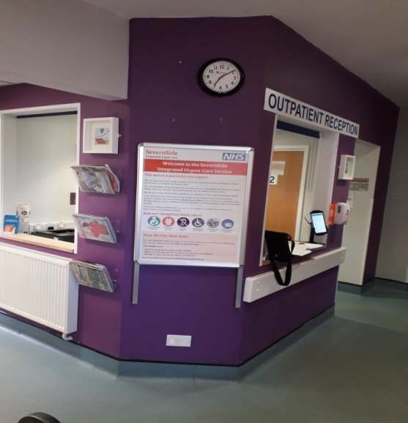
The GP out of Hours Reception Desk is located at the top of the steps on the First Floor of the MIU. The Reception area is equipped with a Computer Workstation, Telephone (Internal and External) Printer, Fax Machine, Confidential Waste Disposal and Filing facilities.
2
Waiting Area
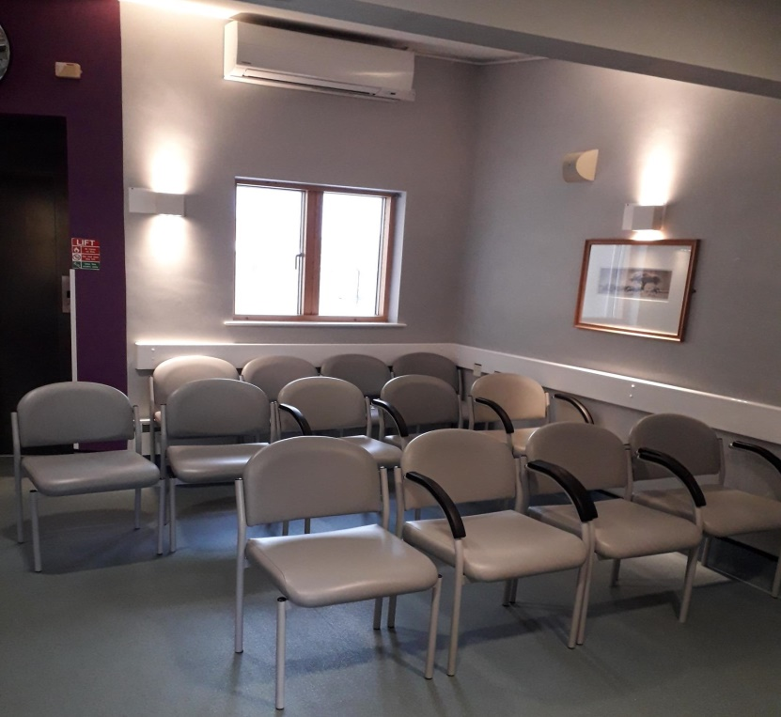
The waiting area seats 10 to 12 people and is situated between the Reception Desk and Consulting rooms. For Patient comfort there is a Television, Chilled Water Dispenser and General Information Displays.
Unisex and Disabled Toilets are adjacent to the seating area to the left of reception as you enter from the stairs.
Consulting Rooms

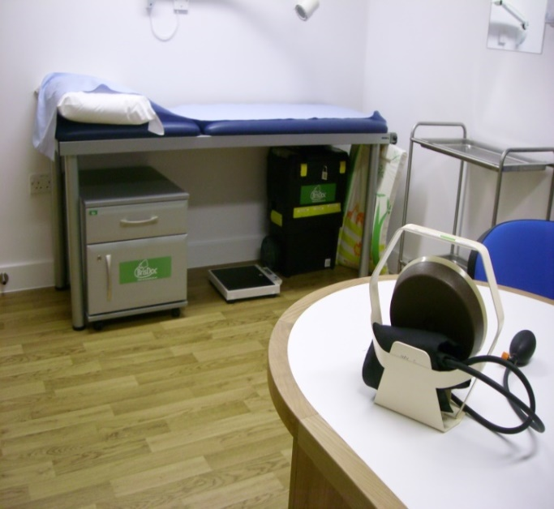
We have the use of 5 fully equipped Consulting Rooms labelled Rooms 1, 2, 3 and 4. And physio room 3
Each room is equipped with a Computer Workstation, Telephone (Internal and External) and Printer.
All Rooms have Clinical Waste Bins and Sharp Boxes
A sluice room is located opposite Reception which should always be used for Urine testing. Clinical Waste can also be deposed of here

3
Consulting Room Equipment
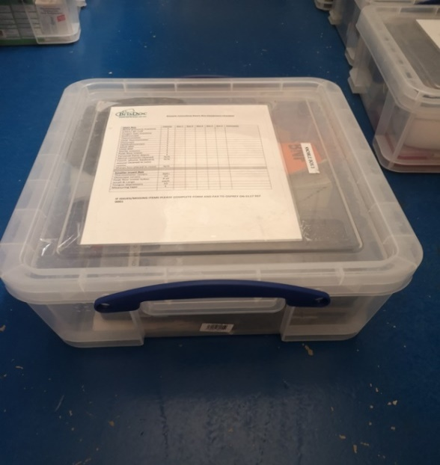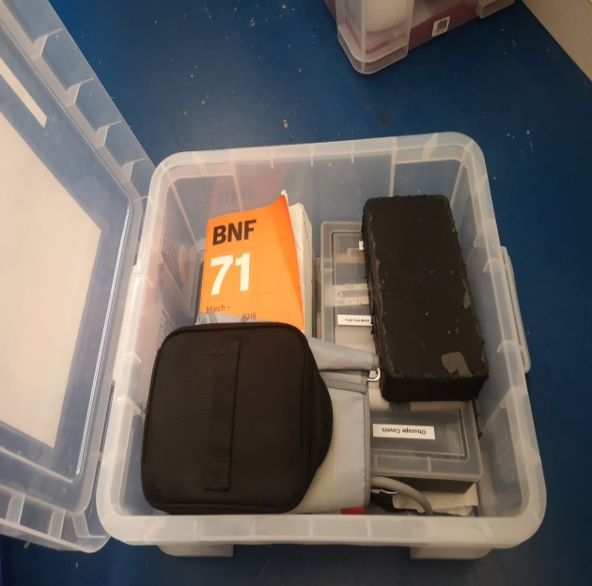
Brisdoc Clinician Boxes are stored in the lockable cupboard at the top of rear stairway. Hosts check that each box is fully stocked before placing them out for use in each Consulting Room at the beginning of the shift.
Storage
Room 3 contains a lockable grey medical cabinet, containing mainly medication and a wooden one, containing mainly consumables.
The keys are kept in the key safe located opposite the storage cupboard at the top of rear stairway. The access code is changed regularly. (See Staff Access section) Also, hung on a hook on the left hand side of the grey cabinet, are the keys needed to access all other parts of the building, including the main entrance.
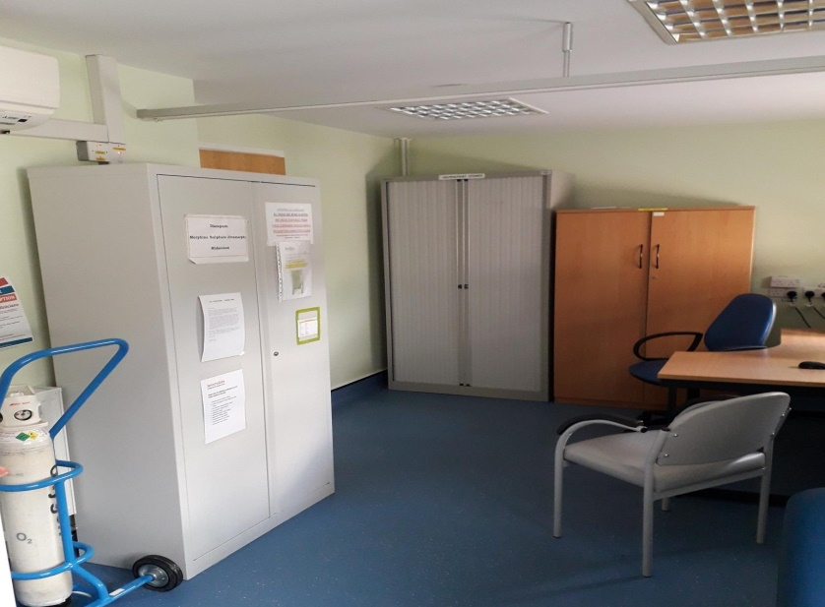
4
There is additional storage space in the store room at the top of the rear stairs just beyond Room 3
Please ensure that care is taken when stacking the boxes in this cupboard to ensure they do not fall against the door when shut making it impossible to open
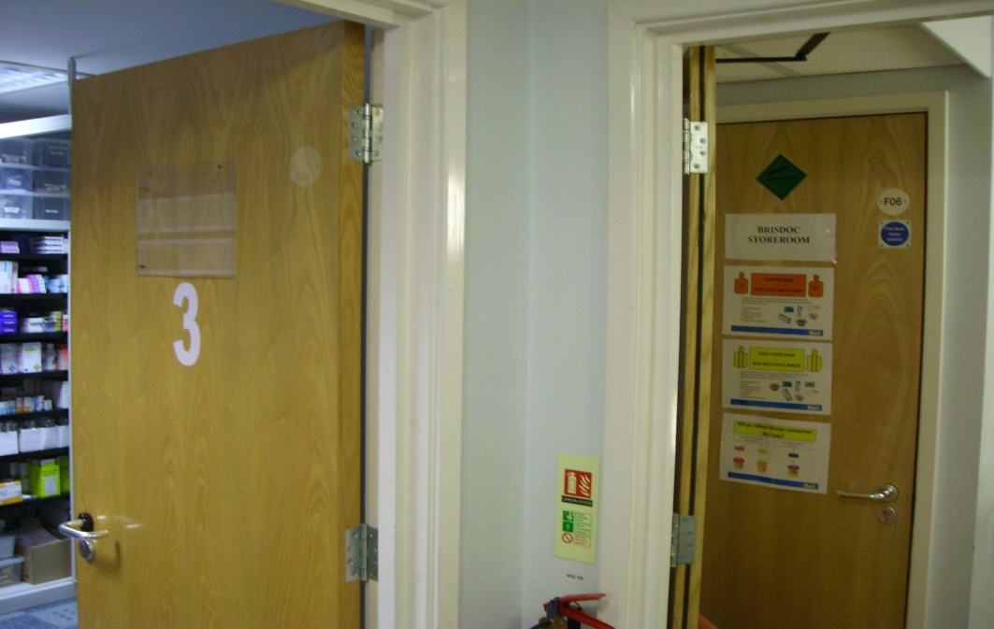
Car Parking
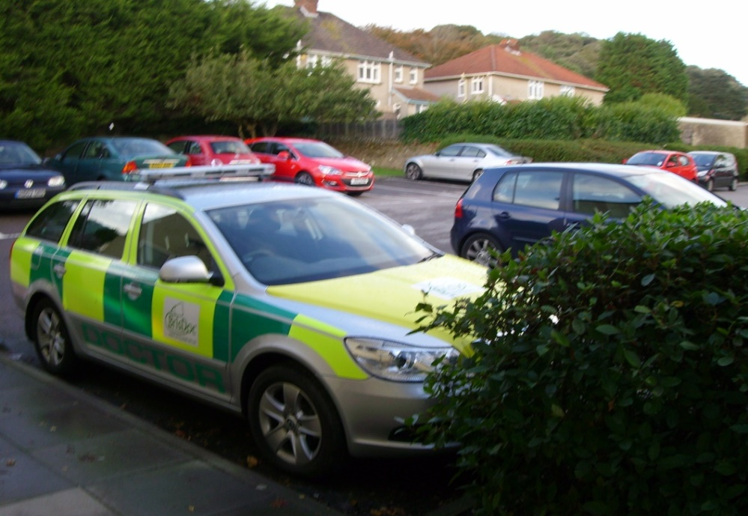

There is adequate parking for OOH Staff. Please avoid using the disabled slots and other designated spaces. No Parking Charges apply.
5
Staff Access

The premises are usually unlocked when we arrive so entry can be via the main entrance. However, we can also enter the building through the rear entrance. This is also how we leave the building at the end of our shift should we be the last to leave. On such occasions, we must ensure the front main doors are locked from the inside.
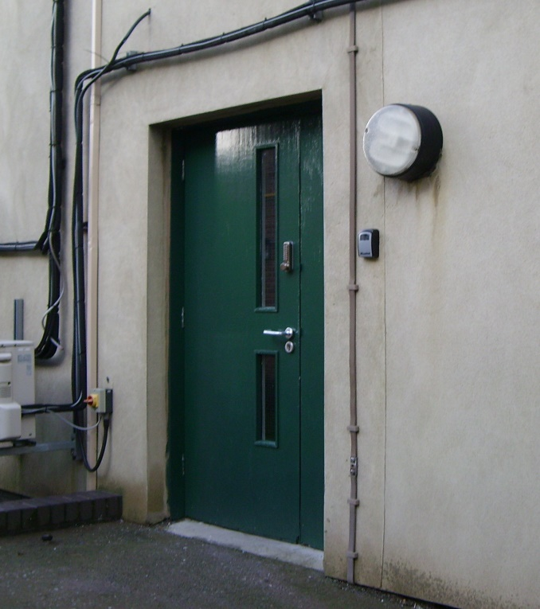
The rear door is unlocked by entering a code which is changed regularly*. There is no alarm to be deactivated.
A key safe is located at the top of the rear stairs, to the right of the fire door and directly opposite the storage cupboard. The code to open the safe is also changed regularly*.
This safe contains the key to the grey medication cabinet in Room 3 which in turn holds all other keys needed such as Petty Cash Tin and Front main entrance. These keys are kept on a hook on the left hand side
*Any Staff who need the access codes are advised whenever they are changed, usually on a six month basis. The code is always available from the Shift Manager

Patient Access
Patient access is through the front door which is also the entrance to the MIU.
There is a CCTV Camera so that patients can be observed before admitting them.
When the MIU is closed the front door is locked and access is requested via an intercom.
The Patients press the buzzer which alerts the Host to lift the handset to talk to the patient and then press the button to open the door.

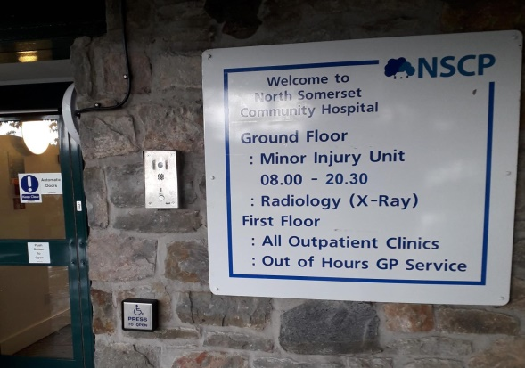

6
Logging in PC’s and loading Adastra
Switch each PC on and after booting up, the Windows log in page will display requiring User name and passwords. The User name that is applicable to each PC is shown below. They are unique to each machine and it is essential that the correct details are entered for any particular machine
Location of PC | User name | Password
Reception | NSomerset\L81051.Brisdoc5 | Please note the same password is needed for each of these User names.  The same password also reactivates any screen when it goes into sleep mode  All Staff who need the password are advised whenever they are changed and the current password is always available from the Shift Manager
Consulting Room 1 | NSomerset\L81051.Brisdoc1
Consulting Room 2 | NSomerset\L81051.Brisdoc2
Consulting Room 3 | NSomerset\L81051.Brisdoc3
Consulting Room 4 | NSomerset\L81051.Brisdoc4

A short time after entering the User name and Password the desktop will appear Selecting the weblinks collage icon will enable you to access all other applications
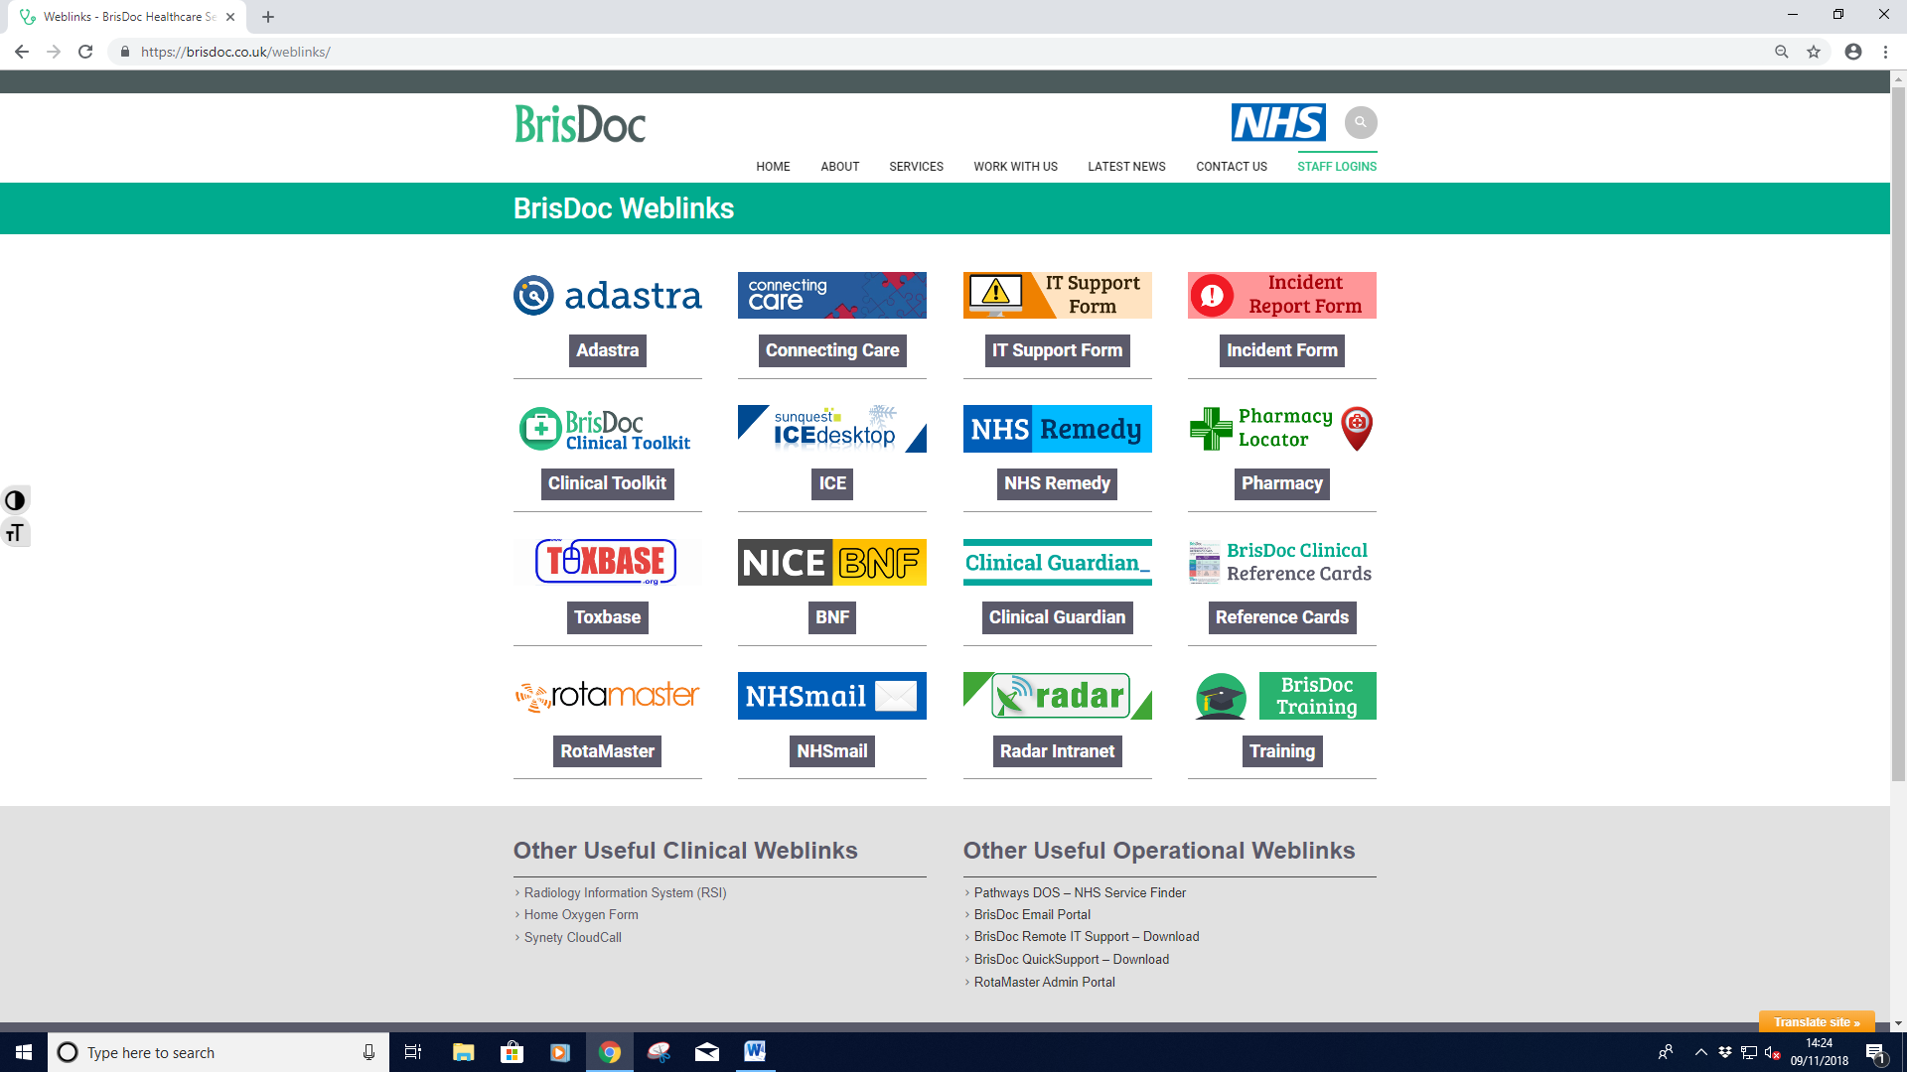
If this collage does not display, it can always be found by typing https://brisdoc.co.uk/weblinks into any search engine
7

From this collage, click onto the Adastra on the top left of the page, which will take you to the NetScaler Gateway

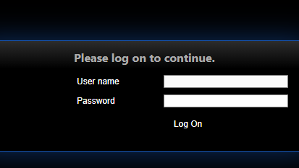
- Entering User name Bdocv3ooh and Password Br1stolH0st to take you to the Adastra Login

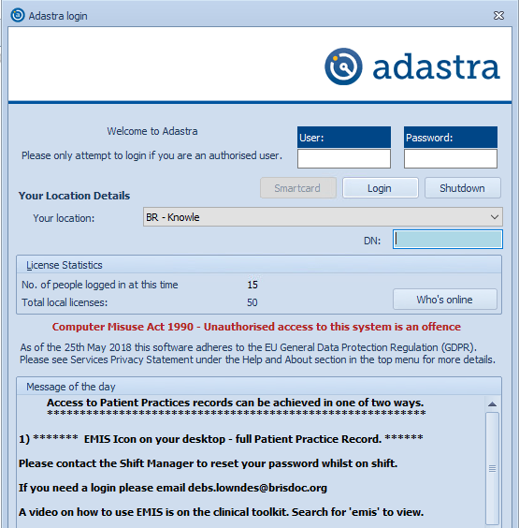
- To proceed beyond this point individual Usernames and Passwords are needed

- Entering the wrong password more than three times will resort in the User being locked out of the system

- Shift Managers are able to unblock users and reset passwords if required

8
Logging in Telephones through Synety
The telephones in each room need to be logged into the Synety system with is accessed by clicking on “Synety Cloudcall” which is located under “Other Useful Clinical Weblinks” in the greyed out section at the bottom left of the weblinks collage
The following log in page should now be displayed

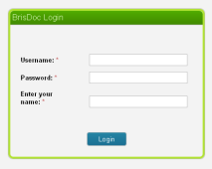

Now enter the appropriate User name from the list below followed by the password and the name of the person who will be using the telephone
Location of Telephone | User name | Password
Reception | bd-clevedon-host | Please note the same password is needed for each of these User names.  All Staff who need the password are advised whenever they are changed and the current password is always available from the Shift Manager
Consulting Room 1 | bd-clevedon-doctor1
Consulting Room 2 | bd-clevedon-doctor4
Consulting Room 3 | bd-clevedon-doctor3
Consulting Room 4 | bd-clevedon-doctor2

9
I.T. Equipment and Telephone/Fax Issues
Clevedon PC’s, Monitors, Printers, Servers and Networks are all managed by Avon IM&T’s Helpdesk. Unfortunately they do not provide OOH support arrangements.
If you are unable to resolve any IT or Telephony problems locally you must provide the Shift Manager with details of the problem. Should you jointly be unable to resolve the issue you need to escalate the matter to BrisDoc’s IT Manager by completing and submitting an IT Support Form which can be found on RADAR at the top left hand side of the homepage.
Please provide as much detail as you can including screenshots where possible.
Prescription Management
Manual and Printer prescriptions are stored in clearly labelled plastic wallets and safely stored in a plastic box kept on the bottom shelf of the grey medication cabinet in Consulting Room 3. All prescriptions must be locked away when we vacate the building at the end of our shift
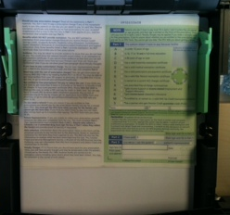
For ease of recognition, Printer Prescriptions are stored in clear plastic wallets and Manual Prescriptions in blue ones. The box also contains the book used to record the daily audit of current numbers of Manual Prescriptions. Manual Prescriptions are for use in the event of a printer malfunction.

Outside Edge
The Printer Prescriptions must always be loaded into the correct printer drawer s as shown.
If needed a Test script can be printed through Adasta by using the “Print Alignment” option from the OOH Operations Drop Down menu
Please be aware that the day time users from Out Patients may leave their own scripts in the 4 printers that we use (Consulting Rooms 1, 2, 3 and 4).
It is very important that these are removed at the start and replaced at the end of each shift and that only our own scripts are used.
10

Medical Equipment

All of the following Medical Equipment are checked and cleaned as part of the Host’s pre-shift checks. A Daily Equipment Checklist is completed to this effect

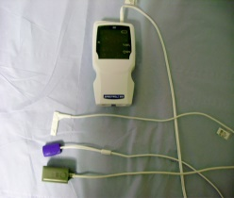
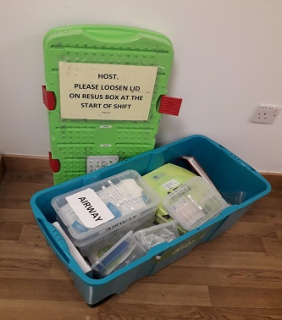

Paediatric Sp02 Machine – kept in a plastic container and located on the bottom shelf of the medication cabinet in Consulting Room 3
.
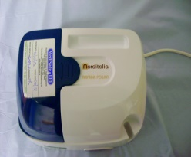

Defibrillation Machine – Kept in the Resus Box, see above

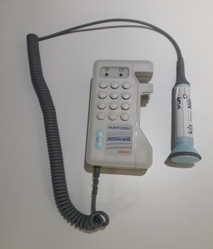
Resuscitation Box – located in the store room at the top of the rear stairs just beyond Room 3.
This must be placed in the corridor at the beginning of each shift for easy access in case of emergency.

Nebuliser Machine – kept on the bottom shelf of the medication cabinet in Consulting Room 3.

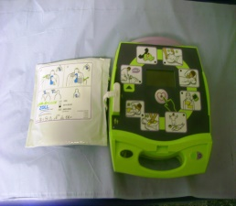

Sonicaid (Doppler) Machine - kept in a plastic container and located on the bottom shelf of the medication cabinet in Consulting Room 3.
11
Locking Up Procedure
The Base shares premises with Clevedon Hospital MIU which is open 08.00 - 21.00, 7 days a week, 365 days a year.
This means that although the main doors will invariably already be unlocked at commencement of our shifts we will be responsible for the security of the building from 2100 daily until we close later that night
When MIU finish at 2100 their staff will adjust the door before they leave so that it only opens when approached from the inside (exit only mode).
They do this by setting the switch to the “Night” position – See photo below.
Admission to the building can then only be made on request via the intercom.
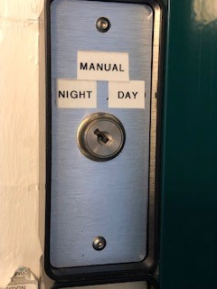
At the end of our shift we must close all windows and fully secure the building.
Before leaving we must then double check that the MIU Staff have set the switch to the “Night” position as above.
We need then to fully secure the doors using the central door lock.
Both keys needed to do this are kept on the key ring with the red fob which should then be returned to the grey medication cabinet in Room 3 before leaving
Please note that should we ever close before MIU we must let them know we are leaving early so that they can fully secure the premises when they leave
Staff Facilities
There is a small Kitchenette adjacent to Reception which contains a microwave, fridge and tea & coffee making facilities. Please ensure you tidy up after use ensuring that you leave the facility in the same state as you would wish to find it.
Brisdoc supplies Tea, coffee, milk and sugar
12
Fire Protocol and Fire Procedures
Local Fire Procedures apply and are clearly displayed to the side of the main door into Reception and the emergency exits. The assembly point is in the main Car Park.
In general, on discovering a fire, the following procedure should be followed: -
- The person discovering the fire should alert other members of staff by shouting “Fire” and if possible activate the nearest fire alarm

- Immediately upon establishing that there is a fire someone should dial 999 and ask for the fire service. You should clearly state that we are an OOH GP Surgery, located on the first floor of the MIU at Clevedon Community Hospital.

- Persons in the vicinity of the fire should assist in evacuating all patients/children.

- The main lift should not be used

- Patients unable to evacuate due to disability, injury or impassable escape route should be moved to the “Safe Area” at the top of each stair well where the Fire Brigade can reach them quickly and easily

- Only if safe to do so, help in closing all windows and doors as you leave..

- Only use firefighting equipment (extinguishers) if safe to do so and you have received training.

- The assembly point is in the main Car Park.

- Do not leave the assembly point or re-enter the Building until advised to do so by the coordinating authorities

Breast Feeding
Should a Patient require privacy for Breast Feeding you should first identify an appropriate room that is vacant and available for use.
Check that the room is clear of any sensitive data and escort the patient/visitor to the room. If the woman is a patient please put a note on Adastra to advise the Clinician of where to find her. Ensure the room is tidied after use
Accident Book
The Accident Book is a legal document that is used to record details of injuries from accidents at work that employers must report under the Reporting of Injuries, Diseases and Dangerous Occurrences Regulations (RIDDOR).
The Accident Book is kept in the Host’s Drawer in Reception
13
Incident Reporting
It is the responsibility of all staff employed by BrisDoc to report incidents, significant events, and near misses. It is our duty to report any incidents in which we have been directly involved or those of which we are aware.
Incidents are raised by completing an Incident Report Forms through RADAR
Visitors Signing In Book
The Visitors Signing In Book is kept in the Host’s Drawer in Reception. Please ensure all Visitors are signed in and issued with a pass for the duration of their visit.
(Should a Brisdoc employee forget their ID Pass they must sign in as a visitor and wear a visitors badge for the duration of their shift)
First Aid Kit
The First Aid Kit is kept on the shelf on the right hand side of the far wall in Room 3 (last room on left)
Business Continuity Kit
In the event of a systems failure a Memory Stick containing everything needed to ensure the operation can continue is located in the Petty Cash Tin, which is itself located on the bottom shelf of the grey medications cabinet in Consulting Room 3
Hard copies of the required paperwork are kept in the rear of the expanding fax record file which is stored in the top drawer of Host’s desk.
Intranet – Radar
Radar is our Intranet system which will allow you to easily access information to help you in your role as well as information about Brisdoc. You will find resources such as Standard Operating Procedures, standard forms, minutes from meetings, role based policies, useful telephone numbers and other useful information.
When you first log on you will be greeted by the radar homepage and if you have any alerts that require your attention, a pop up box will appear

14

